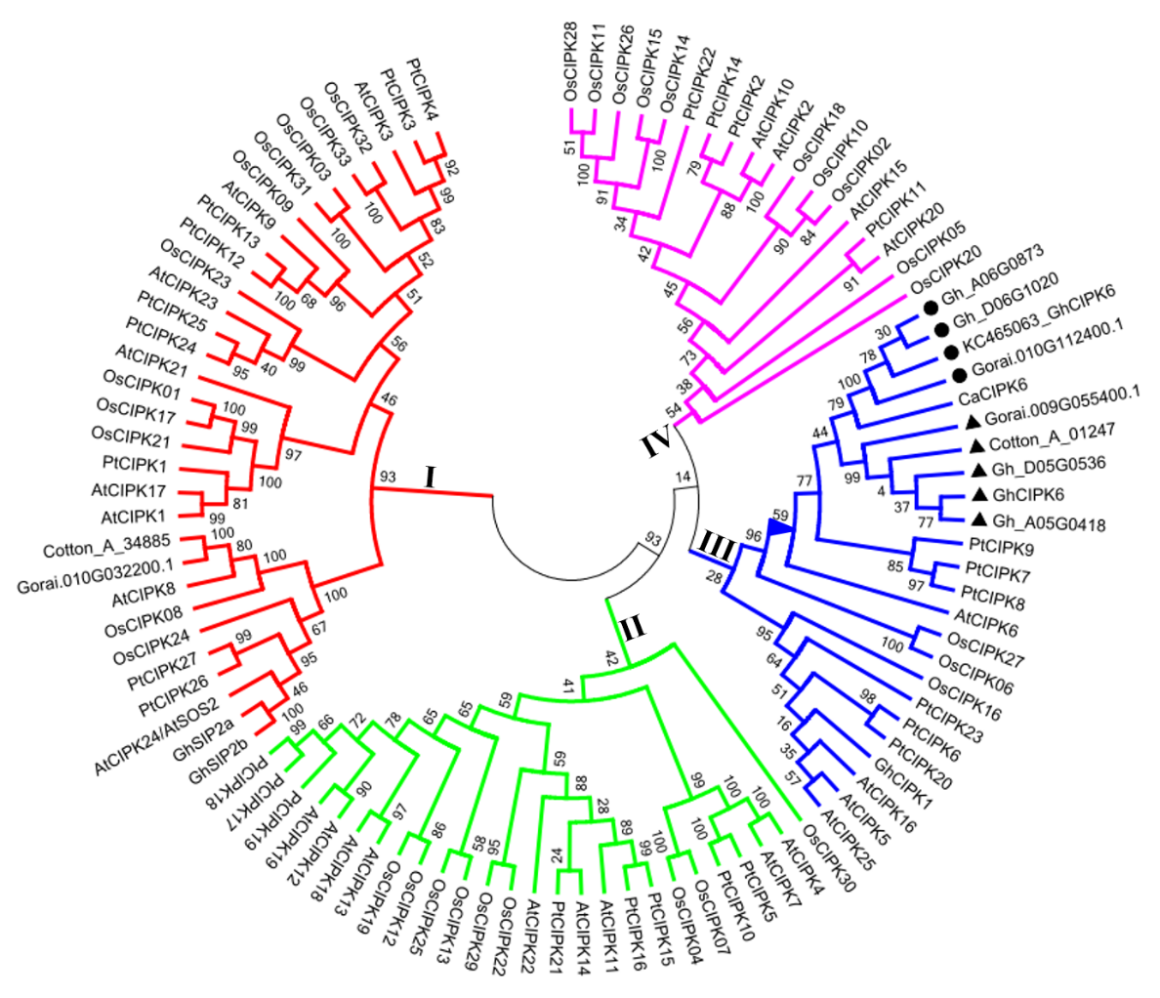
Additional file 6 Figure S1. Phylogenic analysis of GhCIPK6 and CIPK homolog proteins from other species. Full-length amino acid sequences were aligned using the integrated ClustalW and phylogenetic tree was constructed using the neighbor-joining method implemented in MEGA5.2 (1,000 bootstrap test replicates). Black triangles indicated GhCIPK6 and homologs from the A₂, D₅, and AD₁ genomes, respectively. Black circles indicated KC465063_GhCIPK6, and homologs from the D₅ and AD₁ genomes, respectively. The percentage of replicate trees was shown at the branches. Different colored branches represented different groups. Proteins, located in the branch marked by a blue triangle, were chosen for multiple alignments using DNAMAN software. At, Arabidopsis thaliana; Ca, Cicer arietinum; Pt, Populus trichocarpa; Os, Oryza sativa; Gh, G. hirsutum (AD₁); Cotton_A, G. arboreum (A₂); Gorai, G. raimondii (D₅).
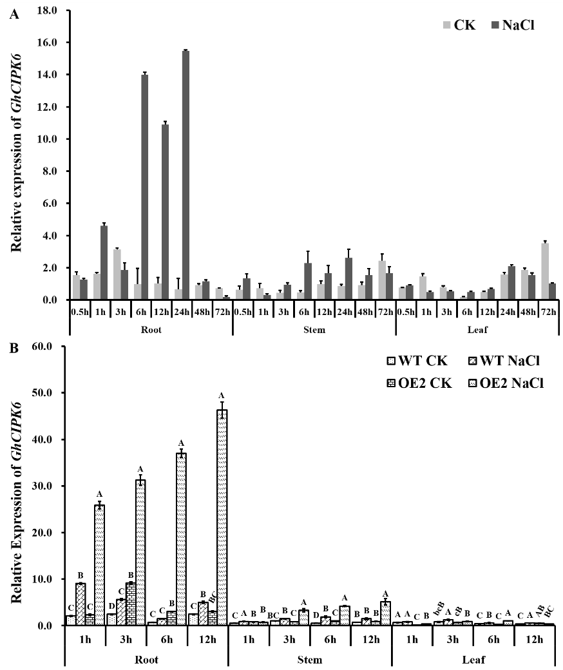
Additional file 7 Figure S2. Expression analysis of GhCIPK6 in different tissues after salt treatment. A. Expression analysis in Upland cotton cultivar ‘Zhong G5’; B. Expression profile in OE1, OE2 and wild-type lines.

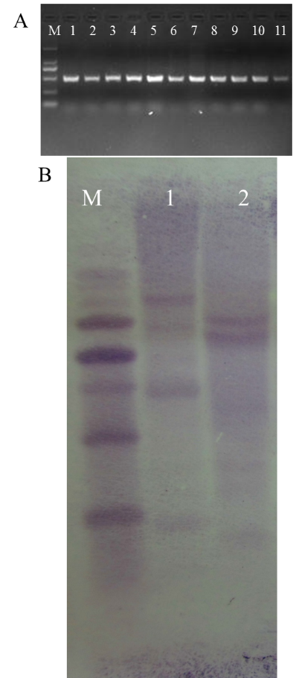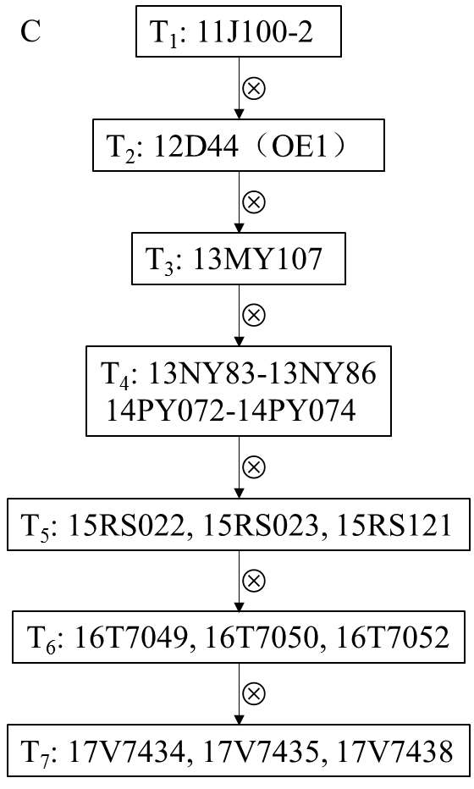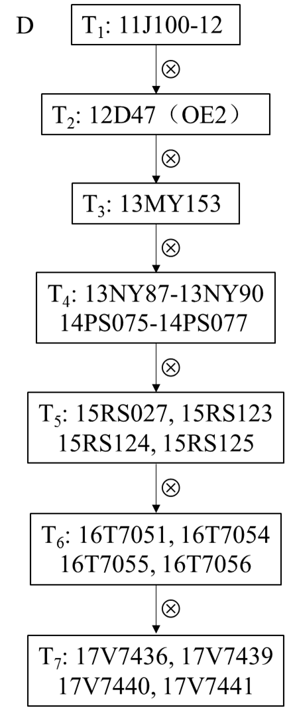
Additional file 8 Figure S3. PCR analysis and Southern blotting assay of positive transgenic plants. A. Identification of positive T₁ transgenic plants by amplifying the resistant gene NPTII. M: D2000 DNA ladder; 1-11, positive individuals, respectively. B. Southern blotting assay of transgenic cotton plants using the resistance gene NPTII as the probe. M: D2000 DNA ladder; 1, OE1 (12D44); 2, OE2 (12D47). C and D. The genealogical diagram of OE1 (12D44) and OE2 (12D47) lines.
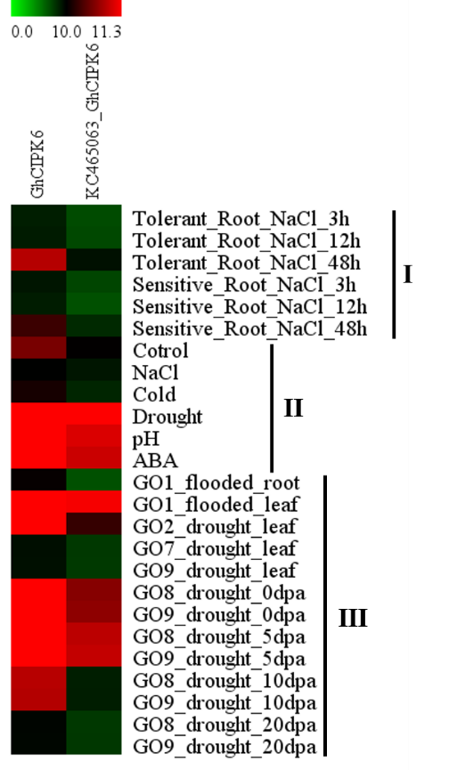
Additional file 9 Figure S4. Expression profiles of GhCIPK6s under abiotic stress using public datasets. I, public data from PLEXdb. II, GSE50770, analyzed the crosstalk between genes that are responsive to multiple abiotic stresses, including ABA, cold, drought, salinity, and alkalinity (pH) in G. hirsutum. III, Transcriptome analysis between roots of the salt-tolerant cultivar ‘Zhong 07’ and salt-sensitive cultivar ‘Zhong G5’ after 3, 12, and 48 h of 150 mmol L⁻¹ NaCl treatment.
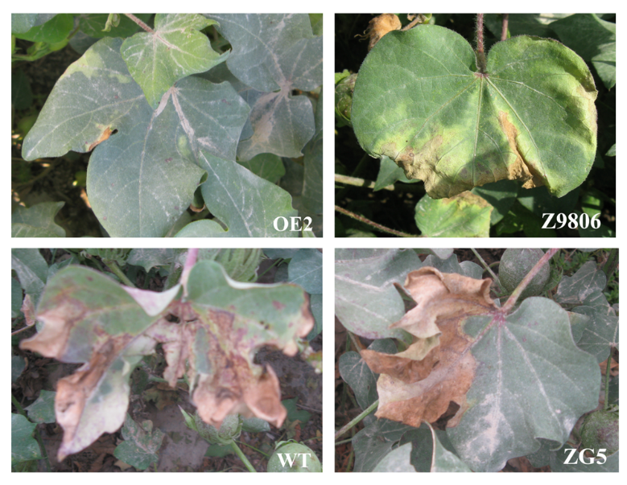
Additional file 10 Figure S5. Salt tolerance assay of transgenic and control cottons during flowering and boll setting stage in the field in Akesu, Xinjiang Province, China in 2013. The salt content of the soil under the surface 5 to 10 cm was approximately 0.92%. WT, wild type line, 11-0516; Z9806, a salt resistant cotton variety; ZG5, a salt sensitive cotton variety.
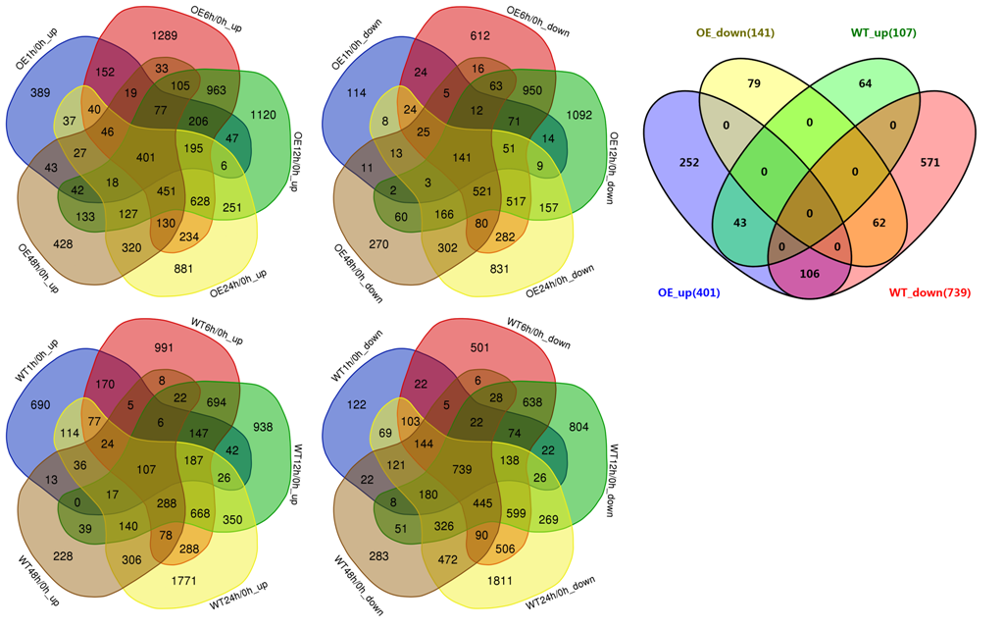
Additional file 11 Figure S6. Venn diagrams of up- and down-regulated DEGs among different salt stress time points in between OE and WT plants, identified from RNA-seq analysis.
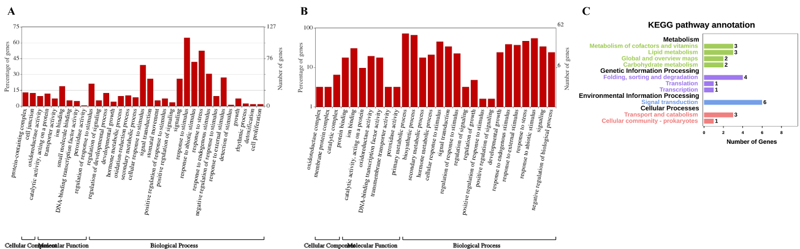
Additional file 12 Figure S7. GO-term and KEGG analysis of up- and down-regulated DEGs. A. GO-term analysis of specific up- and down-regulated DEGs in OE plants following salt treatment. B. KEGG pathway analysis of 78 candidate DEGs.
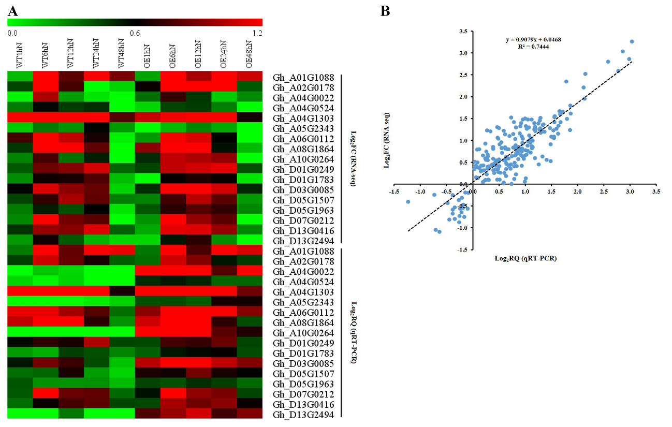
Additional file 13 Figure S8. Validation of express profiles of candidate DEGs by qRT-PCR. A. RNA-seq analysis and qRT-PCR analysis of the co-expressed DEGs in PPI network. B. Correlation of the expression profiles between RNA-seq and qRT-PCR analysis.
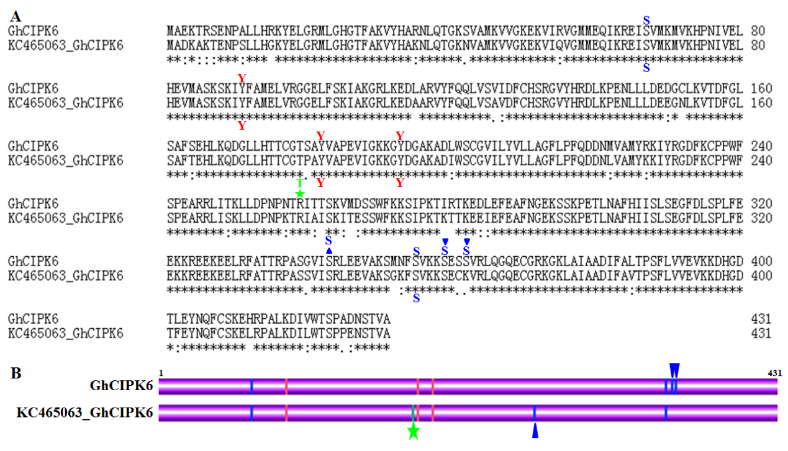
Additional file 14 Figure S9. Analysis of differences in amino acid sequences and phosphorylation sites between GhCIPK6 (present study) and KC465063_GhCIPK6. A. Sequence alignment of GhCIPK6 (this study) and KC465063_GhCIPK6. B. Schematic of predicted phosphorylation sites of GhCIPK6s by KinasePhos (http://kinasephos.mbc.nctu.edu.tw/). The predicted phosphorylation sites were labelled with letters. Serine was represented by “S”, threonine by “T”, and tyrosine by “Y”. Differences in predicted phosphorylation sites between GhCIPK6 (this study) and KC465063_GhCIPK6 are marked with geometric shapes. Differences in serine residues are marked with a blue triangle, and differences in threonine residues are marked with a green pentacle.

